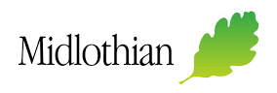
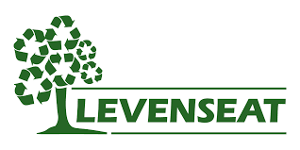

Levenseat / Midlothian Council
Community Waste Fund
£500 is available from the Levenseat Community Waste Fund to assist projects in Midlothian involved in reuse, reuse and recycling of waste, waste prevention activities or community engagement to help local residents better manage their waste.
Please use the form below to outline how your organisation would utilise the funding.
Please return the completed form to recycling@midlothian.gov.uk by 15 September 2023.

Contact name
Contact telephone number
Contact email address
Organisation name
Organisation address
Charity registration number (if applicable)
Project summary
Provide a summary of the proposed project.

Detail how your project will assist residents to reduce, reuse or recycle their waste.

Detail what the funding will be used for.

Material stream targeted
Eg: general waste, paper, furniture, clothes

How will you promote your project to the wider community?

Name:
Position:
Date:

- Projects should demonstrate how they can assist Midlothian Council residents to reduce waste and/or improve quality and quantity of recycling.
- Successful applicants will be expected to participate in promotional activities.
- A total of more than £500 may be available where projects demonstrate clear aims and objectives and/or fewer applications to the total fund available are received.

