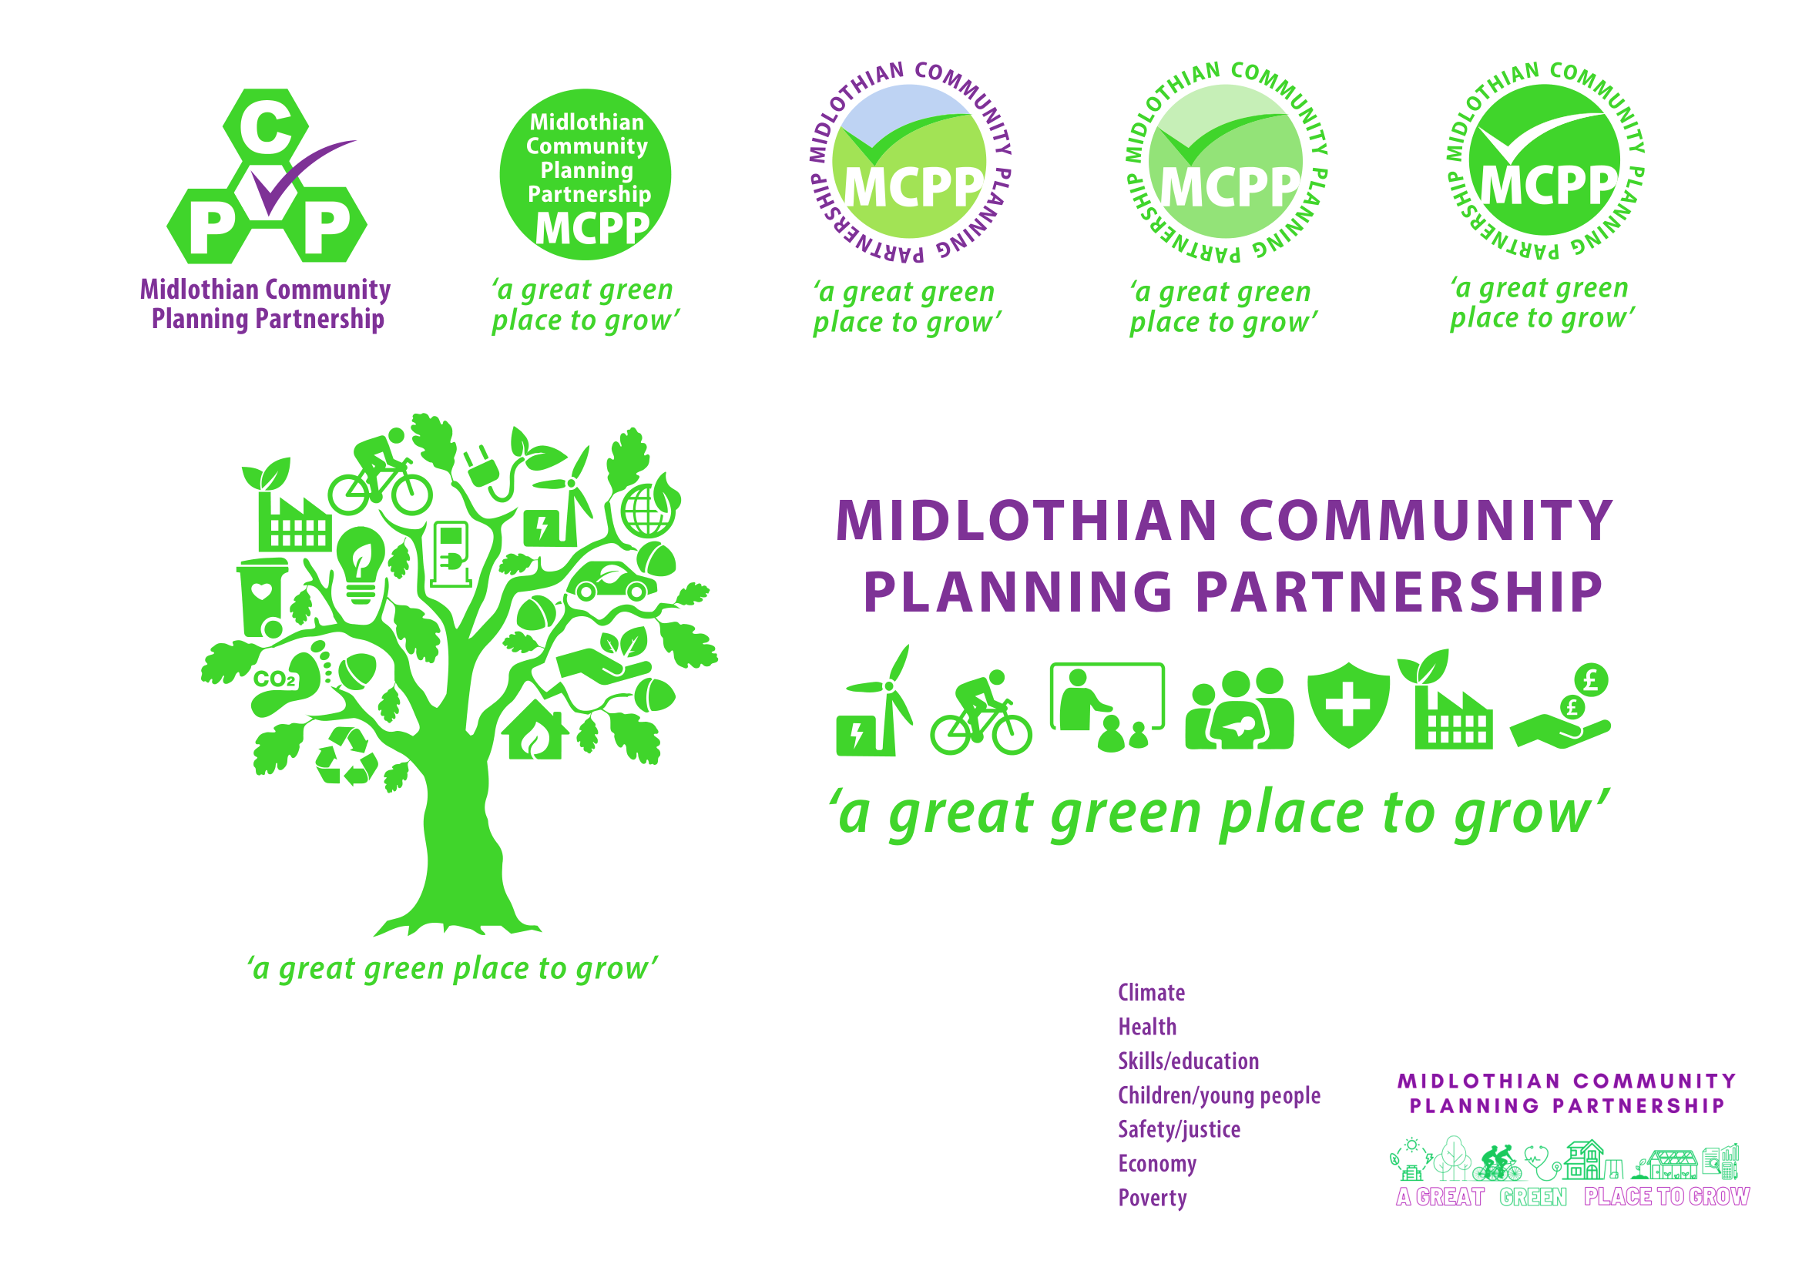**Community Planning Partnership Board Meeting**

**Wednesday 11th September 2024 at 09.30am via Microsoft Teams**

**Present:** Annette Lang, Dona Milne, Grace Vickers, Jim Sherval, Joan Tranent, Joanna Findlay, Kevin Anderson, Lesley Kelly, Lynsey Davidson, Margot Russell, Karen Soar, Penelope Curtis, , Fiona Robertson, Michelle Strong, Peter Smaill, David Virgo, Colin Cassidy, Ann Stewart-Kmicha, Caroline Robb

**Apologies:** Audrey Cumberford, Dave McCallum, Fiona Kennedy, Garry Clark, Jane Burnett, Julian Holbrook, Keith Fisken, Morag Barrow, Pauline Winchester, Roddy Henry

| **Item** | **Minutes** | **Action** |
| --- | --- | --- |
| Approval of Minutes  Matters Arising | Minutes of previous meeting were approved and no matters arising. |  |
| Action Log | Annette Lang presented the action log to the Board and items were updated. |  |
| CPWG Update and asks | Lesley Kelly gave an update from the August Community Planning Working Group meeting. Discussions were had on the most recent Ukrainian and Afghan data and the current funding environment. Annette Lang presented the data overview of Central Dalkeith and Woodburn which is on todays agenda. Asks of the Board included the issue of transport links within communities, lack of ESOL funding for refugees, upcoming regional CP meeting; keeping open facilities; and to revisit the funding risk paper. | AL/LK to take forward action on funding risk paper |
| Director of Public Health Annual Report 2023 | Jim Sherval presented the Director of Public Health Annual Report 2023 which provided key themes and messages. The report is intended to be a useful source of demographic information for public, voluntary and community sector partners in Lothian to shape local policy and service discussions. Please see the attached presentation and link to report:  [Director of Public Health Annual Report 2023 (nhslothian.scot)](https://gbr01.safelinks.protection.outlook.com/?url=https%3A%2F%2Fservices.nhslothian.scot%2Fpublichealth%2Fwp-content%2Fuploads%2Fsites%2F105%2F2024%2F04%2FDirector-of-Public-Health-Annual-Report-2023.pdf&data=05%7C02%7CRebekah.Sullivan%40midlothian.gov.uk%7C862c3823ad1f480e613808dcccc01469%7Cc91025ed4c064329af7ce7ca8df9b8c5%7C0%7C0%7C638610372698692883%7CUnknown%7CTWFpbGZsb3d8eyJWIjoiMC4wLjAwMDAiLCJQIjoiV2luMzIiLCJBTiI6Ik1haWwiLCJXVCI6Mn0%3D%7C0%7C%7C%7C&sdata=3raHoHB%2F54dKI8oUbjUKX8ftKHc6kdeONPxPasnOkyk%3D&reserved=0) |  |
| Population Health Framework | Dona Milne presented the population health framework. Improvements in population health have stalled and Scotland’s health is worsening. The population health framework for Scotland spans 2024 until 2034 with a purpose to accelerate the improvement and recovery of population health in Scotland through a coherent long-term framework of whole system, primary preventative action.  Questions were posed to the Board and responses are to be sent to Dona Milne.  For more details on the framework please email community.planning@midlothian.gov.uk |  |
| Central Dalkeith and Woodburn | AL provided an overview of the presentation on Central Dalkeith and Woodburn. The presentation highlighted current data and statistics from the CPOP website, current support on offer, what we haven’t captured yet, and what actions could we take to reduce poverty |  |
| City Deal | [City Region Deal Annual Report 2023/24 (interactive version)](https://indd.adobe.com/view/494be6da-1885-4423-b022-e28701544050)  [City Region Deal Annual Report 2023/24 [PDF, 2.3MB]](https://esescityregiondeal.org.uk/s/City_Region_Deal_AnnualReport_202324_A4_01.pdf)  [City Region Deal Progress Report - 30 August 2024 (PDF, 476KB]](https://esescityregiondeal.org.uk/s/54-appendix-ESESCR-Deal-Progress-Report-30-August-24.pdf) |  |
| AOB | Woodburn Pantry - 27 September for our Macmillan Coffee morning to meet the team and have cake and a cuppa |  |
| Date of Next Meeting | 24th October 2024, 10am via Teams |  |