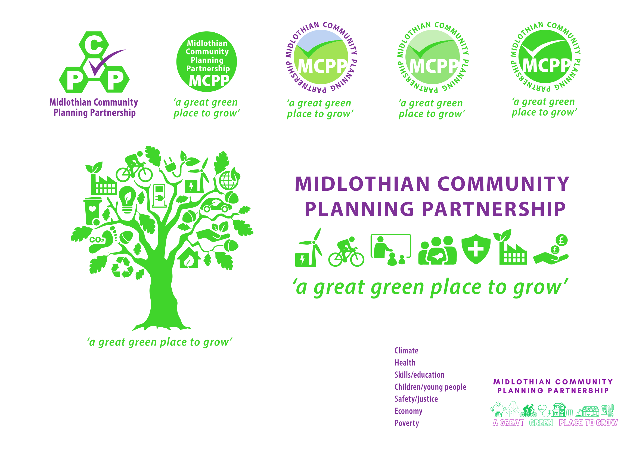**Community Planning Partnership Board Meeting**

**Thursday 5th December 2024 at 10.00am via Microsoft Teams**

**Present:** Annette Lang, Grace Vickers, Jim Sherval, Lesley Kelly, Fiona Robertson, Michelle Strong, Peter Smaill, David Virgo, Colin Cassidy, Ann Stewart-Kmicha, Rebecca Hooton, Fiona Kennedy, Brian Pottenger, Claire Ross, Wendy Campbell, Karen McGowan, Annie Watt, Julie Jessup, Dee Keiran, Nick Clater, Duncan Stainbank, Gill Main, Jane Burnett, Keith Fisken

**Apologies:** Dave McCallum, Garry Clark, Julian Holbrook, , Morag Barrow, Pauline Winchester, Roddy Henry, Dona Milnes, Grace Cowan, Lynsey Davidson, John Fortune, Mark McMullen, Micheal Jeffery, Rebekah Sullivan, Kevin Anderson,

| **Agenda Item** | **Minutes** | **Action** |
| --- | --- | --- |
| Approval of Minutes  Matters Arising | The Board approved the previous minutes of the meeting and the only matter arising was the risk paper which is on the agenda. |  |
| Action Log  6 Month Annual Report  Risk register | The CP Board reviewed the action log and agreed the following actions:   * Business gateway would continue to present updates to the Board * Agree approach for Citizens Panel survey for 2025 * To keep the Sestrans actions on the log * Nick Clater will establish the Equally Steering Group meetings going forward * The learning estate strategic work can be removed from the action log * Good Food nation work would continue to meet every two months and the group would review widening the steering group. * Climate Change Action Hub will provided an update in 2025   The Board acknowledge receipt of the 6 Month Annual Report and recognised that this was for a 6 month period due to the transition from a yearly SMP to a 4 yearly plan.  The Board reviewed the risk descriptors, internal controls, risk scores and status. The Board did not change any of the scores or statuses. Analysis of annual attendance will be required early 2025 for the 2024 year. The Board recognised that the self evaluation session may also generate additional internal control measures going forward. |  |
| CPWG Update and Asks  Funding update paper | Lesley as Chair of the CPWG outlined the items covering at the recent meeting on 21st November 2024. This included information from Lorraine Chapman on asylum seekers. Midlothian has been allocated 186 beds for asylum seekers across 12 properties. 90% of those arriving are single men and women. These individuals have no recourse to public funds and are only entitled to an aspire card with £46 per week for food. Properties can be shared by individuals who are not related and individuals cannot apply for benefits, housing etc  If visa are rejected individuals come under umbrella of destitution.70% of visa applications are positive but 30% will be rejected with responses taking around 6/7 months. There was a request by the CPWG for information to be provided on what met and did not meet the criteria of no recourse to public funds. Lorraine had agreed she would include this in discussions to the working group.  The CPWG also discusses the whole systems approach to diabetes and the CLD Plan.  The CPWG also wished to highlight the report produced by Annette and Lesley on the funding risks. Lesley provided the following presentation to the Board based on the risk paper developed. The Board are to consider the asks from the CPWG regarding the risk presentation. | Board to review the asks of funding risks and respond to Lesley directly with suggestions |
| Single Midlothian Plan Reporting  Publishing H1 Report | Rebecca Hooton introduced her new role as the strategic lead for community planning which she has taken on following JT retirement. Community planning forms part of Rebeccas role as Chief Officer Children’s Services, Partnership and Communities.  Each thematic lead presented their H1 Single Midlothian Plan for scrutiny and governance. They outlined their successes and challenges from April 24 to September 24. For further details please email community.planning@midlothian.gov.uk  The Community Planning Board recognised and thanked the thematic leads for the very positive performance information. The Board acknowledged the positive impact this work has had on local communities.  It was recognised that there is a lot of information for the panel to scrutinised and alternative ways of reporting could be looked at during the Improvement Service at the self evaluation session. | GV to set up a meeting to discuss the healthier theme of CP and the strategic intent with MB & GC |
| Community Planning Conference Report | This item has been carried over to the next meeting  This will be picked up in matters arising in the January meeting. | Item to be included on January agenda |
| CLD Strategic Plan | Michelle Strong outlined the statutory duty that the Council and partners to produce a 3 year CLD Plan. A draft plan was present to the CP Board for approval. The Plan recognises the positive work progressed on the previous 3 year plan, acknowledges the findings of the CLD National Review, and details over 1,000 individuals and stakeholders consultation responses. The CLD Plan contains a measurable set of actions reaching across the 3 years of the Plan. The Board approved the CLD Plan which will now be presented to Council for approval. |  |
| Audit Scotland Report – presented by Chief Internal Auditor | Duncan Stainbank presented the Audit Scotland Report, please email [community.planning@midlothian.gov.uk](mailto:community.planning@midlothian.gov.uk) for more details.  Jim Sherval highlighted the need to provide time to discuss this report further as it forms the core work of community planning. | Create space for follow up discussion on January agenda |
| The Multiagency Transformation Steering Group Update | Grace Vickers provided an update on the role of this group which is one of the main forums for responding to the aspects outlined in the above Audit Scotland Report. Grace will provide updates on the group at future CP Board meetings. |  |
| CP National Self Evaluation Assessment | The group reviewed the potential dates and provisionally agreed the 24th March 2025. |  |
| AOB  Proposed 2025 CP Board meeting dates | 30/01/25; 27/03/25; 05/06/25; 11/09/25; 23/10/25; 04/12/25 |  |
| 1. Date of Next Meeting | 30/01/25 |  |